Oro Valley Interscholastic Mountain Bike Club

Non-Profit Corporation under 501(c)(3)

Canyon del Oro High School Cross Middle School Mountain View High School
Ironwood Ridge High School Wilson K-8 Basis Oro Valley
Pusch Ridge Christian Academy Leman Academy Coronado Middle School
Marana High School Homeschool Casas Christian School
2024 Sponsorship Packet
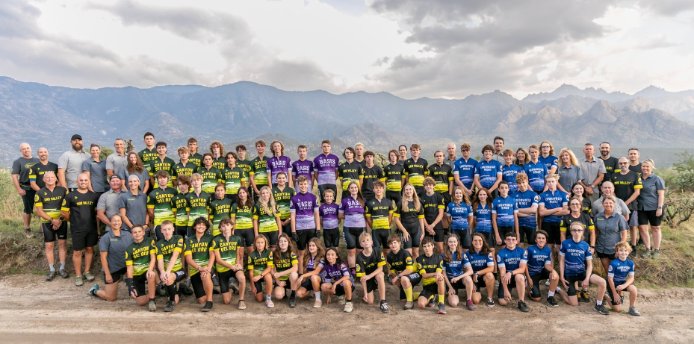

www.ovmtb.org | www.arizonacycling.org
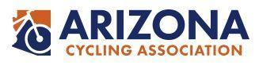

Kendra Vossler, President and Katie McMurrich, Vice President
Oro Valley Interscholastic Mountain Bike Club (OVMTB)
Arizona Cycling Association
Dear Potential Sponsor,
We are writing to you on behalf of Oro Valley Interscholastic Mountain Bike Club (OVMTB), an organization that is working hard to bring more student-athletes to the sport of cycling via friendly, interscholastic mountain bike racing. The opportunity that the Arizona Cycling Association (previously the Arizona Interscholastic Cycling League) brings to our local schools is immeasurable. We have participated in the 2013 (inaugural) season through the 2023 season and increased the number of student athletes each year to a high of 68 middle and high school students. Our members (students and families) have become active in the cycling community, taking part time jobs at local bike shops, and performing trail maintenance and advocacy.
We’d like to make the 2024 season our best yet, reaching more student-athletes and giving them the best possible team experience, and to achieve that we need your help.
Your donation will bring us closer to our goal of $13,575. We are extremely thankful to our repeat sponsors, local business owners and community leaders that have been with us since the beginning. But with our growing numbers, we must continue to raise funds to support all of the student athletes that are interested in pursuing this great sport. You can be a part of that growth by supporting our youth with a donation that fits your budget.
We are happy to acknowledge your donation on our website, social media, team banners, printed materials, and our team t-shirts. We promise to make you proud of your participation - via our racing results, positive attitude, and our outgoing community involvement.
OVMTB is a Non-Profit Corporation under 501(c)(3) and Public Charity under 170(b)(1)(A)(vi). Every donation will be given a Tax-Deductible Donation Receipt.
Thank you,
Kendra and Katie

Mission Statement
We are an inclusive club focusing on the development of young men and women via the sport of mountain bike racing. We use mountain biking to bring kids together, enabling them to grow confidence, environmental awareness, fitness, and friendship.

2024 Arizona Cycling Association Season Schedule
.

Race 1: September 7-8 - Flagstaff – Fort Tuthill County Park

Race 2: September 21-22 - Prescott – Pioneer Park

Race 3: October 5-6 - Secret trails -Snowflake-Taylor

Race 4: October 19-20 - McDowell– Fountain Hills

High School Championship: November 2-3 - Wren Arena - Fort Huachuca

Community Outreach and Other Events
Aside from racing, the OVMTB club supports various local trail building and maintenance efforts (IMBA, SDMB, and MBAA) as well as other local cycling events. We actively worked with the city of Oro Valley, the Honeybee Canyon HOA, Pima County, and Sonoran Desert Mountain Bicyclists in an effort to help establish reliable access to the Honeybee/Rail-X trails through the new Big Wash parking lot and trail, as well as help to build a mountain-bike specific race and event venue at McKenzie Ranch. We’re also involved with the Oro Valley Parks & Recreation Department, planning future bicycle-related events such as a Bike Swap and summer bike camp for kids.
We definitely would not have the club in such a healthy state, with the positive future that it has, without everyone who supports us! Cheers to the sponsors, families, and friends who all gave in some way to OVMTB!
Thank you for your time!

Estimated 2024 Expenses
Mountain biking (and cycling in general) can have a steep cost of admission but can become a lifelong pursuit that enables healthy active lifestyles and environmental awareness. Every dollar that we raise goes to lowering the cost of getting the student athletes out on the trails.
Estimated expenses are listed below:
Team Registration | $300
Food for Pitzone | $600
Race entry fees – 60 riders x $150 | $9,000
T-shirts & Banner | $1,500
Equipment | $575
End of Season Party & Senior Gifts | $600
Misc. – Insurance, Sponsor Gifts | $1,000
Total | $13,575

Sponsorship Levels and Options

Titanium Sponsor - $2500 Plus
Sponsor receives prominent logo recognition on banner, club t-shirt, website & plaque.

Carbon Fiber Sponsor - $1500
Sponsor receives logo recognition on banner, club t-shirt, website & framed club picture.

Steel Sponsor - $1000
Sponsor receives logo recognition on banner, club t-shirts & website.

Chain Ring Sponsor - $500
Sponsor receives listing on banner, club t-shirts & website.
*All sponsors will receive social media recognition via likes, callouts, and hashtags if desired.
Donations of cycling gear are welcomed as well.

2024 Oro Valley Interscholastic Mountain Bike Club

Sponsor Form

____________________________, Company
____________________________, Sponsor Level
____________________________, Amount enclosed
____________________________, OVMTB Rider

Please make checks payable to OVMTB. For your convenience, contact Wendy Mccoskey Sponsorship Coordinator (520-465-4909) for pickup or mail to:
OVMTB ℅ Laura Jewett
623 W Sonatina Ln
Oro Valley, Az 85737

All donations made prior to July 15th, 2024, will be placed on the club shirts and banners. We greatly appreciate your support for our kids.
Tax-Deductible Donation Receipt for 501(c)(3) letters will be mailed to each sponsor by August 30, 2024.
If you have any questions regarding our organization or our fund management policy, please feel free to contact us at coachovmtb@gmail.com.

